**BEEE EXPERIMENTS LAB FILE**

Experiment 4: Bluetooth controlled LED

Circuit Diagram:

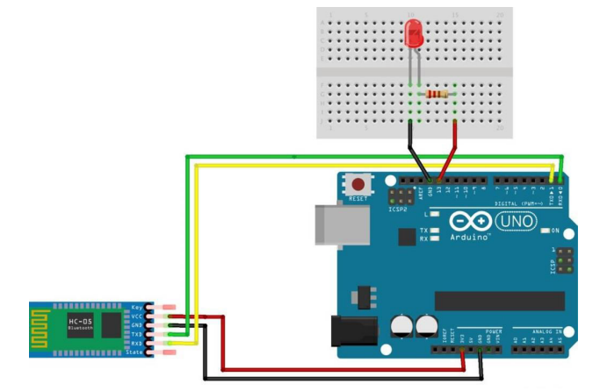

**THEORY**

**CONCEPTS USED:**

1. A circuit is made using Bluetooth and arduino.
2. Tx of Bluetooth is connected to 0 of arduino. Ground of Bluetooth is connected to ground of arduino. And VCC(high voltage) is connected 5V of arduino
3. Connection of BLUETOOTH to arduino.
4. Appropriate value of resistance is required.
5. Coding in ARDUINO IDE so as to use Bluetooth.
6. The use of multimeter to check connections.

**LEARNING AND OBSERVATIONS:**

1. Making circuits using Arduino and Bluetooth.
2. Connecting Bluetooth to arduino.
3. Signals are transmitted from Bluetooth to arduino.
4. Bluetooth receives the signals by Rx(0).
5. Coding to be done on Arduino.exe for stimulation of the experiment.
6. The working of ARDUINO and its coding.
7. Not using resistances can damage the circuits by excessive flow of current.
8. Breadboard connections can get shorted if the circuit is not proper.

**PROBLEMS AND TROUBLESHOOTING:**

No problem occurred during the execution of the experiment.

**PRECAUTIONS:**

1. Wrong connections of Bluetooth ports can lead to failure of experiment.
2. Port Selection for Arduino can be incorrect due to which it won’t upload on Arduino Board and resulting in failure of experiment.
3. LED should be in forward bias.
4. The workplace are should be dry and not in close proximity to water.
5. Breadboard connections should not be short circuited.
6. Make sure the connections are appropriate and there is no loose connection.

**LEARNING OUTCOMES:**

1. Using Bluetooth.
2. Connection of Bluetooth to Arduino and the knowledge of different ports of Bluetooth.
3. Working and coding of Arduino.
4. The use of breadboard for making connections
5. Using multimeter to see if the circuit is closed or not.
6. I now have appropriate knowledge about the working of Bluetooth.
7. I now have appropriate knowledge about wiring and connections.